

MAHARASHTRA STATE BOARD OF TECHNICAL EDUCATION (MSBTE).

YEAR- 2022-2023

INDUSTRIAL TRAINING REPORT

ON M/s Santosh ELECTRICALS,

kudal .

SUBMITTED BY:

Rahul Vishwambhar Prabhu (TYEE)

ENrollment NO. 2101170306

SUBMITTED TO:

DEPARTMENT OF ELECTRICAL ENGINEERING

GOVENRMENT POLYTECHNIC MALVAN,

maharashtra. 416 606



Maharashtra state board of technical education

# **Certificate of completion of Industrial Training**

This is to certify that Mr. Rahul Vishwambhar Prabhu with Enrollment No. 2101170306 has successfully completed Industrial Training (22049) in M/s SANTOSH ELECTRICALS from 12/06/2023 to 24/07/2023 for partial fulfillment towards completion of Diploma in ELECTRICAL ENGINEERING from GOVERNMENT POLYTECHNIC MALVAN

Institute code -0117

sign sign

Head of the Department Head of the institute

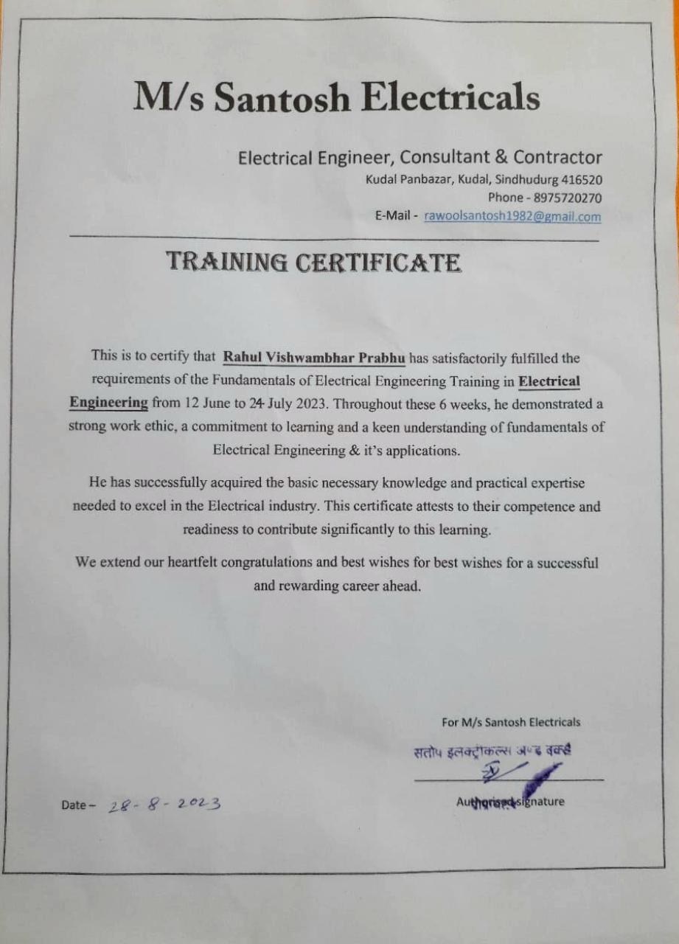Industrial training certificate given by firm

# **DECLARATION**

I hereby declare that the report on the “Report on, M/s SANTOSH ELECTRICALS”. Submitted to the department of Electrical Engineering, Government Polytechnic, Malvan is based on my own work, carried out during course of our study. This report is prepared under the guidance of our teachers and HOD. The work done has not been submitted to any other institution for any other degree/diploma/certificate in this university or any other university of India. We have followed all the instruction and guidelines given by the mentor and the as per mentioned in syllabus for preparing this report. Whenever I have used the resources or material from other sources, we have given due credit to them in the text of the along with their details in the reference section.

Date. 05 /08/2023

Place. Malvan

**Student Name:** Rahul Vishwambhar Prabhu

**Enrollment No.** 2101170306

# **Abstract**

Industrial training course is introduced to all diploma programmes with an objective to develop the traits of industry culture among the students before they enter into world of industry. By exposing and interacting with the real-life industrial setting, student will appreciate and understand the actual working of and industry, best practices adopted in industry. An electrical contractor is a businessperson or firm that performs specialized construction work related to the design, installation, and maintenance of electrical systems. An electrical contractor is different from an electrician; an electrician is an individual tradesman, and an electrical contractor is a business person or company that employs electricians. Both usually hold licenses and insurances to properly and safely operate a business, protecting the employees and home owners/business owners from insurance liabilities. These requirements vary from state to state. Electricians may work for an electrical contractor, or directly for individuals or companies. I am well satisfied with my training. I have learned many new technical subjects, acquired a number of new technical skills and improved another group of existing skills, other than those gained at university laboratories. What I liked most about my training is that it is very strongly related to academic materials and laboratories we studied in the university. This refutes the common saying that very little of the materials taught in university engineering courses is used by engineers working in the labour market. This dependency (relationship) is clearest in engineering design and development, which is the nature of work in electrical contractor firm. However, this does not mean that I have learned little new things in my training. I may count the technical skills that I learned or improved at the training site, other than those gained at university laboratories.

# **ACKNOWLEDGEMENT**

# It gives me a great sense of pleasure to present the Industrial training report after 2nd Year. I owe special debt of gratitude to Dr . Y. V. Mahadik and Mr. Ingole sir. (Government polytechnic, Malvan). For his constant support and guidance throughout the course of work his sincerity, thoroughness and perseverance have been a constant source of inspiration for us. Is only his cognizant efforts that our endeavours have seen light of day.

# I also take the opportunity to acknowledge the contribution of acknowledge the contribution of My Industry Guide Mr. Sandip Parab . For his full support and assistance during the Industrial Training. We also do not like to miss the opportunity to acknowledge the contribution of all Employees/faculty members of the M/s SANTOSH ELECTRICALS Kudal. And department of electrical engineering for their king assistance and cooperation during the training. Last but not the least; I acknowledge my friends and my family members for their contribution in completion of the training report.

# **________________________**

Mr. Rahul Prabhu

TYEE - 210117030

Table of Contents

**Certificate of completion of Industrial Training**................................................**II**

INDUSTRIAL TRAINING CERTIFICATE GIVEN BY FIRM……………………………………...**III**

DECLARATION....................................................................................................**IV**

Abstract……………………………………………………………………………..……………………….….**V**

ACKNOWLEDGEMENT………………………………………………………..…………………………..**VI**

**Chapter 1**

1.1 Organizational structure of Industry/Organization and General layout……..**IX**

1.2 Organogram…………………………………………………………..…………………………………**X**

**Chapter 2**

2.1 Introduction of Industry/Organization………………………………………………..……**XI**

**Chapter 3**

3.1 My responsibilities and work on the site. & What I have learned from this apprenticeship...................................................................................................**XIII**

**Chapter 4**

4.1 Testing of raw materials, components and finished products along with quality assurance procedures.......................................................................................**XX**

4.2 Tools used in casing capping Conduit Wiring…………………………………………...**XX**

**Chapter 5**

5.1 Safety procedures followed and safety gear used......................................**XXI**

**Chapter 6**

6.1 Impact of Engineering and Learned Skills in Training.................................**XXIII**

**Chapter 7**

7.1 Conclusion.................................................................................................**XXVI**

**List of figure**

Figure no. 1 cleat wiring…………………………………………………………………………….**XVI**

Figure no. 2 casing capping wiring……………………………………………………………..**XVI**

Figure no. 3 Condit wiring ………………………………..………………………………………**XVII**

Figure no. 4 concealed wiring……………………………………….………………………….. **XVII**

# **Chapter 1.**

## **1.1 Organizational structure of Industry/Organization and General layout.**

An electrical contractor is a person who is trained and usually licensed to perform electrical work. Electricians can choose to work for themselves, for other companies, or electrical contractors. So while an electrical contractor can mean the business, an electrician almost always means an individual. Many electricians will start as apprentices. choose to further their continuing education and training and become masters in the electrical business. Additionally, they have to pick what type of electrician they are going to be, whether they will work with high-voltage or low-voltage installations and management as well as if they are going to work outside or inside. These decisions will impact their careers, training, and licensing. Someone who has spent most of their life as an indoor low-voltage electrician will take on different jobs than an outside technician.

Jobs and Duties of Electrical Contractors and Electricians

* Plan the Project
* they will determine the steps necessary to acquire a permit and finish the job, while factoring in the timelines and resources for those steps. Create Benchmarks
* set the benchmarks for checking success. Distribute Resources
* schedule resources to be available during the appropriate part of the project. Manage the Budget
* manage the budget to keep the project on target. Manage Relationships
* these are the relationships with both the contracting staff and key stakeholders, such as the customer.
* Voice/Data/Video Electrical Contractors – these electricians and electrical contractors are also known as integrated building system electricians. They work with low-voltage systems like power controls, backup power, wireless networks, fiber optics, telecommunications, and security systems, and more.
* Line Electrical Contractors – this is typically outside electrical work and usually includes high-voltage power for transmission and distribution lines at power plants or similar locations. They will make sure that power is getting to homes and buildings.
* Inside Electrical Contractors – these contractors and electricians work within a property, they do cabling, installation, wiring, repair, and maintenance within a lot of different buildings.

# **1.2 Organogram**

**of M/s SANTOSH ELECTRICALS**

**ELECTRIC CONTRACTOR**

.

**ELECTRICTION**

**ELECTRIC SUPERVISOUR**

**HELPER**

**ORGANOGRAM OF M/s SANTOSH ELECTRICALS**

**INTERNS**

**Chapter 2.**

2.1 Introductions of industry / organization

M/s Santosh Electrical is an electric store in Kudal. The owner of this shop is Santosh Rawool. Mr.  Santosh rawool undertakes electric wiring contracts and repairs and maintenance. they do electrical works in domestic wiring. M/s Santosh electrical do wiring of casing capping and concealed type . M/s Santosh electrical has happy and satisfied clients. M/s Santosh electrical contracting is known for good and reasonable work.

----------------------------------------

1.Scope of Work: Electrical contractors are responsible for a variety of tasks, such as electrical system installation, wiring, lighting, power distribution, panel upgrades, and more. They work on projects ranging from new construction and renovations to system upgrades and repairs.   
  
2. Industry Regulations: Electrical contractors must adhere to local, state, and national regulations and codes, which ensure safety standards are met. They need proper licenses and certifications to perform their work legally and maintain compliance with the industry regulations.   
  
3. Skill Requirements: Electrical contracting work demands a high level of technical expertise and knowledge. Electricians need to have a thorough understanding of electrical systems, circuits, wiring, and troubleshooting techniques. They should be skilled in interpreting blueprints and work effectively as part of a team.   
  
4. Safety: Safety is a paramount concern in electrical contract work due to the potential hazards associated with electricity. Contractors must follow safety protocols and ensure that all installations comply with established safety guidelines.

5. Market Demand: The demand for electrical contract work is typically steady, as electricity is a necessity in homes, businesses, and industries. Several factors influence market demand, including population growth, new construction projects, building renovation activities, technological advancements, and energy efficiency initiatives.   
  
6. Competition: The electrical contract work industry can be highly competitive, with numerous firms competing for projects. Contractors often differentiate themselves through their expertise, reputation, quality of workmanship, efficiency, pricing, and customer service.   
  
7. Business Model: Electrical contractors can operate their businesses as single-person enterprises or as larger companies employing multiple electricians and support staff. They may bid on projects directly, partner with general contractors, or subcontract for specific electrical tasks.   
  
8. Technology and Innovation: The electrical contract work industry is evolving with advancements in technology. Contractors are increasingly incorporating smart home systems, renewable energy solutions, energy-efficient lighting, and automation technologies into their offerings.   
  
9. Training and Education: Becoming an electrical contractor typically requires formal training through apprenticeship programs, trade schools, or vocational programs. Many jurisdictions also require electricians to pass licensing exams and undergo continuing education to stay updated on industry practices and regulations.

10. Professional Associations: There are various professional associations, such as the National Electrical Contractors Association (NECA), Electrical Contractors' Association of Ontario (ECAO), and Independent Electrical Contractors (IEC), that provide resources, industry information, networking opportunities, and advocacy for electrical contractors.

**Chapter 3**

**3.1 My responsibilities and work on the site. & What I have learned from this apprenticeship**

My responsibilities on the site is, to help the Electrician. And advice the electrician. And keep focused what is electrician is training me. My responsibilities is to keep all the things on the right position. And neat and clean. To help the electrician and learned new things. And new techniques of work.

I have learned that how to Install Concealed Conduit Electrical Wiring System Properly.

Concealed Conduit Electrical Wiring systems are the most popular, aesthetically appealing, and most common type of House Electrical wiring used. Conduit wiring is a professional way of wiring a building. Mostly PVC conduits are used in domestic wiring. The conduit protects the wires from external damages like rodents etc., increasing the longevity of the wires used. Before talking about the installation procedure, lets talk about what house electrical wiring system is and their different types.

House Electrical wiring is distributing the electricity (electrical energy) from suppliers meter board to various appliances in the home like lights, fans, TV etc., There are lot of different types of house electrical wiring systems used in India and other countries. Few of them are

**Cleat Wiring :-**

Cleats with groves are used to hold the cable. It is a temporary wiring system so not used in typical house constructions.

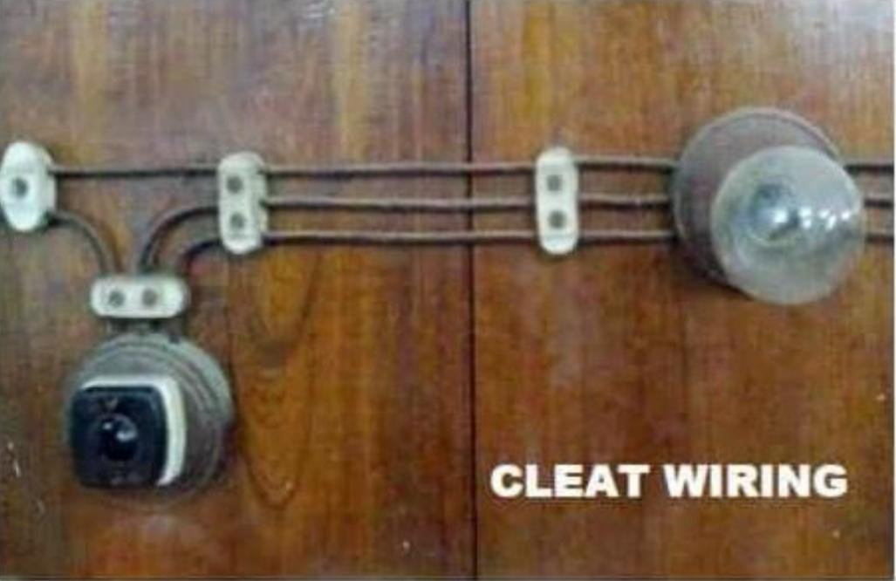

Fig. 1

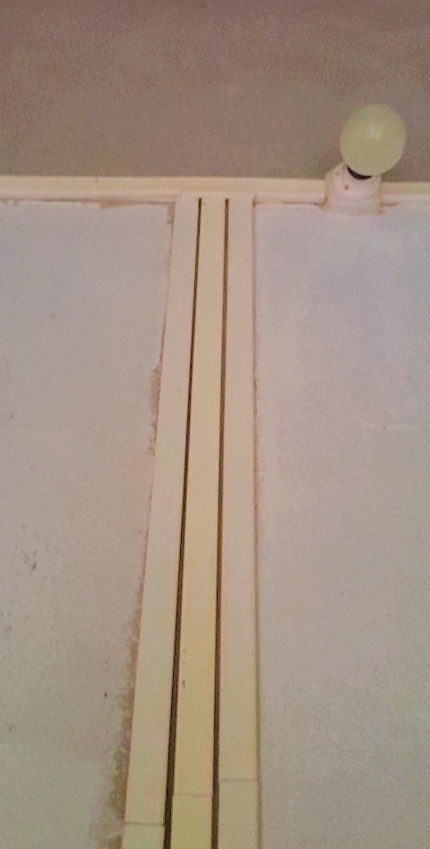**Casing capping wiring :-**

Casing Wiring Open wiring system where the wires are run through casing enclosure and capping is used to cover the casing

Fig. 2

**Surface Conduit Wiring :-**

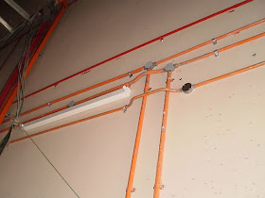PVC or GI conduits are laid on the surface of the wall or ceiling. These conduits are attached to the walls with a 2-hole strap and base clip at a regular certain distances. Electrical wires are laid inside the conduits.

Fig. 3

**Concealed Conduit :-**

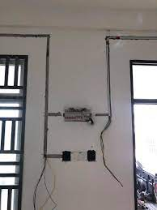Wiring PVC conduit pipes are placed inside the chiselled brick/block wall before plaster. The wall is later completely plastered and painted. Electrical wires are laid inside the conduits. This type of wiring are aesthetically appealing since they are no electrical wires/conduits seen on the top of the wall.

Fig. 4

## **Advantages of casing capping wiring :-**

* This wiring system is way cheaper than a sheathed and conduit wiring system.
* It looks beautiful.
* There is no risk of mechanical shock.
* The alternation is possible in this system.
* It is cheaper compared to a steel conduit and sheeted wiring system.
* It is considered as safe from smoke, dampness, and humidity.
* Customized installation can be done very easily for this system.
* Reduced risk of electric shock can be expected because all the cables are covered.
* This wiring system is cheap and durable.
* It stays safe for oil, steam, smoke, and rain.
* If phase and the neutral wire are installed in the separate slot then repairing is easy.
* Stay for a long time in the field due to the strong installation of casing and capping.
* This wiring system is a strong and long-lasting wiring system.
* Repairing becomes very easy if the phase and neutral wire are installed in separate slots.

## **Disadvantages of casing capping wiring :-**

* Difficulty in finding some fault caused in the wire.
* It is used up to 220V.
* There is a high risk of the casing and capping systems.
* This wiring system is not suitable for acidic conditions in industries.
* There is too much risk of major fire due to short circuits because of plastic in this wiring system.
* The risk of fire is possible.
* The humidity is directly effected by casing and capping, therefore, this wiring system is not used for humidity places.
* The initial cost of the system is high, so it is expensive.
* Costly to repairing and need more materials.
* The material can't be found easily in the contemporary.
* The place of acid and alkaline are present this system is not suitable.
* While ants may damage the casing and capping wood.

**Installing a casing capping wiring system step by step**

**1. Planning and Design:**

- Determine the locations where the casing capping system will be installed.

- Measure the lengths required for the casing capping sections.

- Identify the route and outlets where electrical connections will be made.

**2. Gather Materials and Tools:**

- Obtain the necessary materials, including casing capping sections, connectors, junction boxes, wires, screws, and other accessories.

- Ensure you have the appropriate tools, such as a saw, drill, screwdriver, wire cutters, and a measuring tape.

**3. Turn Off Power:**

- Before starting any electrical work, turn off the power supply to the area where you will be installing the casing capping system. This ensures your safety.

**4. Mark Mounting Points:**

- Use a pencil or marker to mark the location for mounting the casing capping sections on the wall or ceiling.

- Ensure the markings are straight, level, and align with your planned route.

**5. Cut Casing Capping Sections:**

- Using a saw or suitable cutting tool, cut the casing capping sections to the required lengths based on your measurements.

- Make sure to use precise cuts to fit the sections together seamlessly.

**6. Install Mounting Brackets:**

- Attach the mounting brackets to the marked points on the wall or ceiling using screws.

- Ensure the brackets are securely fastened and aligned properly.

**7. Attach Casing Capping Sections:**

- Connect the casing capping sections together using suitable connectors.

- Slide each section into the mounting brackets to secure them in place.

- Ensure a tight and secure fit to prevent any movement or dislodging.

**8. Install Junction Boxes:**

- Identify the locations where junction boxes will be needed, such as for outlets or switches.

- Attach the junction boxes to the wall or ceiling using screws and ensure they are securely fastened.

**9. Route and Connect Wiring:**

- Plan the route of the wiring inside the casing capping system, ensuring it reaches the desired outlets or switches.

- Run the wires through the casing capping sections, keeping them organized and secured using clips or cable ties.

- Make appropriate connections at junction boxes, outlets, and switches by stripping the wires, twisting them together, and using wire nuts or appropriate connectors.

**10. Test and Secure:**

- Once all the wiring connections are made, double-check for any loose or exposed wires and fix them if necessary.

- Turn on the power supply to the area and test all electrical connections to ensure they are functioning correctly.

- Secure any loose sections or wiring using additional screws or clips.

**11. Finishing:**

- If required, paint or conceal the casing capping system to match the surrounding walls or ceiling.

- Ensure the system looks neat and blends with the overall aesthetics of the area.

**Chapter 4**

**4.1 Testing of raw materials, components and finished products along with quality assurance procedures.**

**Materials used in casing capping Wiring:**

* Wooden / pvc board
* Insulation tap
* Junction box
* ceiling rose
* Lamp holder
* PVC cable
* Main switch
* Switch Sockets
* Screws
* KitKat Fuse

**4.2 Tools used in casing capping Wiring:**

* File
* Megger
* Knife
* Hummer
* Hack saw
* Pipe
* Screw
* Wrench
* Drill machine
* Measuring tape
* Combinational plier
* Phase tester

# **Chapter 5**

## **5.1 Safety procedures followed and safety gear used.**

**Precautions of casing capping wiring:**

1Personal Protective Equipment (PPE): It is important to wear appropriate PPE, such as safety goggles, gloves, and protective clothing, to protect against any potential electrical hazards or sharp edges.   
  
2. Proper Handling Techniques: The wiring should be handled with care to avoid any damage or injury. It is important to hold the wiring securely and maintain a firm grip while working with it.   
  
3. Insulation Testing: Before working with casing capping wiring, it is crucial to ensure that the insulation is intact. Insulation testing should be conducted using appropriate insulation test equipment to verify its safety before installation.   
  
4. Power Shutdown: Whenever possible, the power to the area where casing capping wiring is being installed or maintained should be shut down. This helps to minimize the risk of electric shock or short circuits.   
  
5. Circuit Identification: Proper labeling and identification of circuits is essential to prevent accidental contact with live wires. Each wire should be clearly labeled with its corresponding circuit or purpose.   
  
6. Proper Tools and Equipment: It is important to use appropriate tools and equipment when working with casing capping wiring. These may include wire cutters, pliers, screwdrivers, and cable management tools.

7. Secure Installation: Casing capping wiring should be securely installed to prevent it from becoming loose or falling off, posing potential safety hazards. Proper fastening methods and secure attachment to walls or ceilings should be followed.   
  
8. Grounding: Ensure proper grounding of the casing capping wiring system to minimize the risk of electrical shocks or short circuits. Grounding helps redirect any electrical current in case of a fault, protecting against electrical accidents.   
  
9. Regular Inspection and Maintenance: Regular inspections and maintenance should be conducted to identify any potential hazards or signs of wear and tear. Any damaged or faulty casing capping wiring should be replaced promptly to ensure safety.   
  
10. Adherence to Electrical Codes and Regulations: It is essential to follow all applicable electrical codes and regulations when working with casing capping wiring. These codes provide guidelines and requirements for safe installation and maintenance.

# **Chapter 6**

## **6.1 Impact of Engineering and Learned Skills in Training**

My training in SANTOSH ELECTRICALS was very useful to me in acquiring new engineering skills that I had not had before. These learned skills prove being very valuable by signifying an impact in solving problems. It is well known that engineering skills have vital importance in design problems specifically. Some of the areas, problems and difficulties in which the engineering skills I learned signified an impact in solving problems are the following.

* Safety in an electrical device, which may be very necessary, is a common problem that occurs repeatedly and everywhere. An engineer having skills of troubleshooting the device using simple equipment can solve such a problem. I feel that I have improved these skill during the training period. The work of technicians in engineers in Santosh Electrical is not limited to designing and prototyping military-related devices. They also repair any device in the laboratory or elsewhere that goes faulty, if they can. E.g. I have participated in repairing the timer in a paper cutting machine by troubleshooting. This motivated me to try to repair any damaged electrical device in my home.
* When a problem arises where designing a technical project is required, the improved technical skills in using specialized software for simulation, programming, plotting, instrumentation, etc. , and in dealing with hardware become very useful and helpful in increasing design efficiency. Such a project could be an academic project or an industrial project, such as Santosh Electricals projects. Design engineers Santosh Electrical use these skills extensively when working on any project.
* Skills of teamwork and planning are universally desired since they increase the efficiency of any project in terms of time and money.

**COLOR VISION**

Because wires are often color coded, electrical contractors need to be capable of distinguishing between hues for their own safety and to ensure quality work. That said, color-blind electricians do exist. In some situations, they compensate by using equipment (i.e. filters and lights). In some sectors, mission critical wires are also labeled, allowing color-blind electricians to read alphanumeric values rather than relying on hues alone. Where color vision is an explicit requirement for an electrical contractor license, however, color blindness can unfortunately be an insurmountable barrier to entry.

**COMMUNICATION**

Subcontractors of all types need to be effective communicators – and electrical contractors are no exception. From sharing expectations with stakeholders to giving colleagues clear instructions, this skill will be tested in the field every single day. PHYSICAL STRENGTH AND ENDURANCE Electrical contractors often spend many hours on their feet every day. Other physically demanding aspects of the job include: lifting heavy objects maneuvering in hard-to-reach places frequently climbing scaffolding and ladders While electricians don’t have to be Olympians, good physical fitness and stamina is undoubtedly an asset.

**ATTENTION TO DETAIL**

In virtually all types of construction subcontracting, attention to detail ensures not only high-quality work but also safety. This is certainly true of electrical contracting, which involves handling dangerous equipment. Electrical contractors need to have a keen eye for electrical issues and potential safety hazards on job sites, among other important considerations. Cookies consent for gobridgit.com We use cookies on our website to help us provide you with the best, most relevant experience, for analytics and to improve functionality. We may share your information with advertising and analytics partners.

**BUSINESS ACUMEN**

Electrical contractors interested in running their own businesses of course need a variety of administrative skills, including working knowledge of: accounting construction human resource management budgeting project estimating While these may seemingly have little to do with actual electrical work, they can mean the difference between operating a successful subcontracting company and going belly-up.

**MOTOR SKILLS**

Electrical contracting can be very hands-on work. Consequently, workers should possess dexterity and confidence in managing tools of the trade, such as: pliers screwdriver wire strippers power tools cable ties READING COMPREHENSION (INCLUDING SCHEMATICS) Electrical contractors spend a significant amount of time reading documentation, from blueprints and schematics to regulations. Being able to parse these documents and deliver something up to code and the client’s expectations is imperative.

**BASIC TO INTERMEDIATE MATH**

Electrical contractors work with numbers often throughout the day, making quick measurement calculations, converting units as needed, and more. While electrical contracting isn’t rocket science, being able to make these basic to intermediate calculations on the fly is an asset.

**CUSTOMER SERVICE**

Electricians do much of their work in the client’s environment, be it a home, office, or industrial facility. They are often the primary point of interaction between clients and the electrical contracting business. Therefore, it’s important that electrical contractors represent their employers well, which largely boils down to offering good customer service. They should be presentable, professional, and keep their workspace looking the same

# **Chapter 7**

## 7.1 Conclusion

In conclusion, I am well satisfied with my training. I have learned many new technical subjects, acquired a number of new technical skills and improved another group of existing skills, other than those gained at university laboratories. What I liked most about my training is that it is very strongly related to academic materials and laboratories we studied in the university. This refutes the common saying that very little of the materials taught in university engineering courses is used by engineers working in the labors market. This dependency (relationship) is clearest in engineering design and development, which is the nature of work in Firm. However, this does not mean that I have learned little new things in my training. I may count the technical skills that I learned or improved at the training site, other than those gained at university laboratories. During 6 weeks training period, a lot of experience, knowledge and exposure that I have handy. All disclosures were awaken myself in a boost of self-confidence to face life more challenging now. Practical is a complement to the science or theory learned. This is clearly the concept of science and charity, where they have learned without practice will be lost and will not give anything - what effect. So if we do without the knowledge of course there will be problems in terms of grip and stance ever - changing. During my industrial training, there are many changes from the point of learning environments and discussion among colleagues. It can directly increase the dedication and rational attitude toward myself. However, there are still some weaknesses that can be improved in the future. Therefore I conclude that the industrial training program has provided many benefits to students even if there are minor flaws that are somewhat disfiguring condition , so that this weakness can be rectified in the future. I can conclude that this industry is through training I received a lot of exposure in the computing world.